whatAlgoritmizationProgrammingLanguages_PachshenkoGN/1
- Find the arithmetic operator
- Specify the types of operator
- 5+9*3*3-4 > 10 (2+16-8/4 > 6 || (2<6 10>11))
- Logical operators always evaluated from
- When an equation uses more than one type of operator then the order of precedence has to be established with the different types of operators:

- Precedence for Logical Operators
- How many times the current loop will execute? for (int i = 0; i <= 5; i += 3);
- There are two different ways to implement multi selections in C++ language. They are
- What is an array?
- The whole array can be passed to a function. However, it can't be changed by the code in that function.
- A two-dimensional array represents data in the form of table with rows and columns
- Which statement of array is true?

- What are strings?
- In which data type we write text
- Choose the right syntax to define a function
- A function can return more than one value
- What are the three steps in using a function?
- The factorial function.
- write mpg() function prototype, that takes two type double arguments and returns a double
- What is data structure?
- Which of the following are themselves a collection of different data types?
- The data elements in structure are also known as what?
- What will be used when terminating a structure?
- Which of the following is address of operator represented by?
- Pointers may be compared by using relational operators
- What will be used between the object name and the member name?

- Which stream class is used to both read and write on files?

- Which stream class is only used to read files?
- Which of the following shows the correct syntax for if statement?
- When does the code block following while(x<100) execute?
- Which of the following properly declares struct?
- Which of the following properly declares a variable of struct foo?
- Which of the following correctly declares an array?
- What is the difference between array and structure?

- There is an array with 29 elements, what is the index number of the last array element?

- What will output from the following program
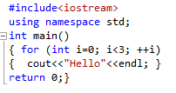?
- How many times the current loop will execute for (int i = 0; i <= 4; i += 3);?
- How many times the current loop will execute<xmp>for (int i = 0; i <= 10; i++);</xmp>?
- What is the output from the following program code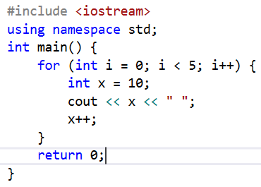?
- What is the output from the following program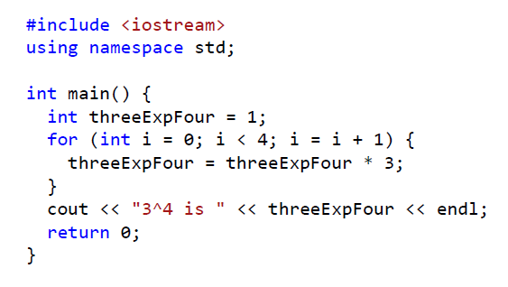?
- Write the correct function definition, where function ‘alua’ that takes three integers, x, y and z, and returns an integer?
- Write correct function prototype for the function ‘intToDouble’ that takes an integer argument ‘number’, and returns a double value.
- The OR (||) operator:

- Which of the following for headers is not valid for C++ code?
- Which conversion is not possible?
- What is the correct way to print integer sum to the screen?
- What will output from the following function printOnNewLine;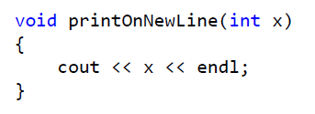, if x = 3?
- Which of the following cannot be used to create a random numbers?
- What is the correct value to return to the operating system upon the successful completion of a program?
- Which of the following gives the value stored at the address pointed to by the pointer gala?
- What is the only function all C++ programs must contain?
- What punctuation is used to signal the beginning and end of code blocks?
- What punctuation ends most lines of C++ code?
- Which of the following is a correct comment?
- Which of the following is not a correct variable type?
- Which of the following is the correct operator to compare two variables?
- Which of the following is true for an integer variable?
- Which of the following is the boolean operator for logical-and?
- Please evaluate !(1 && !(0 || 1)).
- What is the final value of x when the code <xmp>int x; for(x=0; x<50; x++) {} is run?</xmp>
- Which is not a loop structure in C++?
- How many times is a do while loop guaranteed to loop?
- What is the output of the following code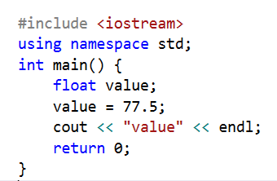?

- What is the return type of the function with prototype: "int func(char x, float v, double t);"
- Which of the following is a valid function call (assuming the function exists)?
- Which of the following is a complete function?
- Which of the following is required to avoid falling through from one case to the next?
- What is the return type of the function with prototype: " float func(char x, float v, double t);"
- Which of the following is the proper declaration of a pointer?
- Which of the following gives the memory address of integer variable a?

- Which of the following gives the memory address of a pointer a?
- Which of the following gives the value stored at the address pointed to by the pointer a?
- Which of the following gives the value stored at the address pointed to by the pointer ptr?
- Which of the following accesses a variable in structure b?
- Which of the following accesses a variable in structure mystruct?
- Which of the following correctly accesses the seventh element stored in alua, an array with 100 elements?
- What character ends all strings?
- What would be printed from the following C++ program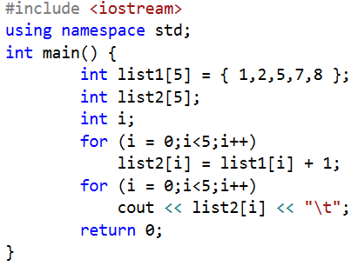?
- What is the correct way to write the condition y < x < z?
- The value 132.54 can represented using which data type?
- What is the index number of the last element of an array with 9 elements?
- What punctuation ends most lines of C++ code?
- Which of the following identifiers (variable names) is invalid?
- In an assignment statement“ a=b; ” which of the following statement is true?
- When following piece of code is executed, what happens, if b=2; a = b++; ?
- Which of the following is output statement in C++?
- Which of the following is input statement in C++?
- The difference between while structure and do structure for looping is
- Which of the following is selection statement in C++?
- Which of the following is not a looping statement in C++?
- Looping in a program means?
- In case of pass by reference

- A function that calls itself for its processing is known as
- We declare a function with ______ if it does not have any return type
- Arguments of a functions are separated with
- The keyword endl
- Strings are character arrays. The last index of it contains the null-terminated character
- Variables inside parenthesis of functions declarations have _____ level access
- Array indexing always starts with the number
- Which of the following accesses a variable in structure st1?
- Which looping process is best used when the number of iterations is known?
- If there is more than one statement in the block of a for loop, which of the following must be placed at the beginning and the ending of the loop block?
- A memory address is…
- The set of instructions that a computer will follow is known as..
- <xmp>cin>> number</xmp>; is
- <xmp>cout<< "How many items would you want?\n";</xmp> is

- int number; is
- If x is 0, what is the value of (!x == 0)?
- Which class should be included to work with files?
- Which of the following is the output from the following C++ code 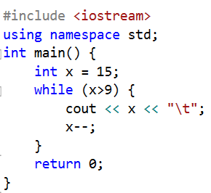?
- If originally x=0,y=1, and z=3, what is the value of x, y, and z after executing the following code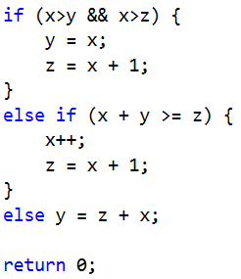?

- What is the value of x after the following statements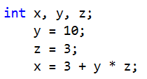?
- What is the value of x after the following statements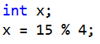?

- Which of the following is the output from the following C++ 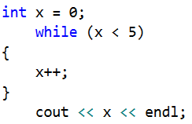?
- Given the code fragment, what is the final value of y? 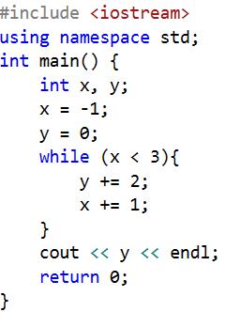

- Which of the following is the output from the following C++ code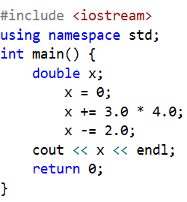?
- Which of the following is the output from the following C++code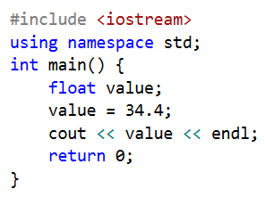?
- What is the final value of y in the following C++code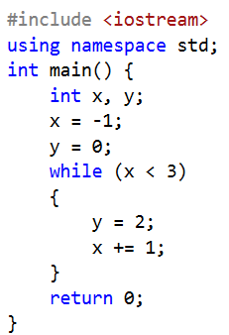?
- Which of the following is the final value of ‘i’ from the following C++code 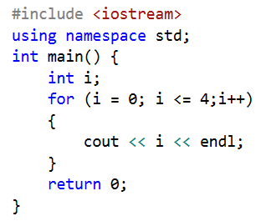?
- What is the value of x after the following code executes 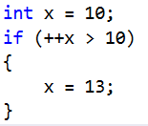?
- What is the output of the following code segment 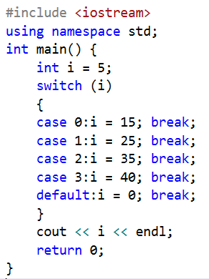?
- What does the following code print to the screen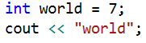?
- What is the value of x after the following statements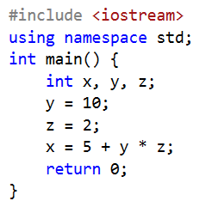?
- What is the value of x after the following statements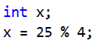?
- What is the value of x after the following code executes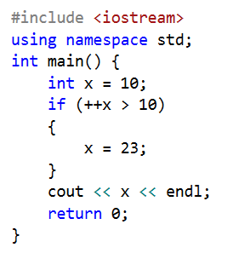?
- Given the code, what is the final value of i? 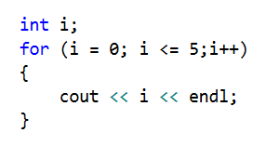
- What is the output of the following code fragment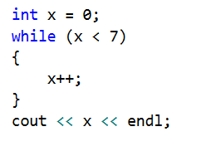?
- Which of the following is the valid array declaration
- What is the output of the following code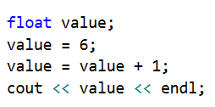?
- What is the value of x after the following statements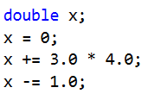?
- What is the output of the following code fragment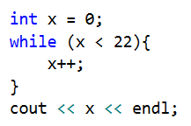?

- Solve the following piece of code and choose the best answer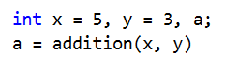?
- If the type specifies of parameters of a function is followed by an ampersand &, that function call is…
- Which of the following gives the memory address of a pointer pt1?
- What is the final value of x after the following fragment of code executes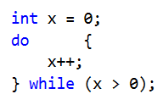?
- What is the value of x after the following statements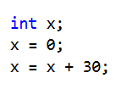?
- Given the following code fragment, what is the output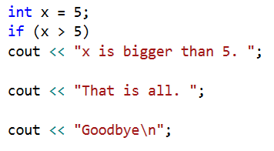?
- How many times is "Hi" printed to the screen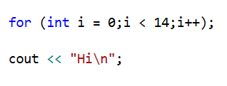?

- Which libraries should be included to get string in a file?
- How to implement array of chars with 10 elements?

- How to get whole string in one line (in command line)?
- How to get whole string in one line (in file)?
- Why do we need library <xmp><fstream></xmp>?
- Why do we need library <xmp><cmath></xmp>?
- Where is the mistake of the code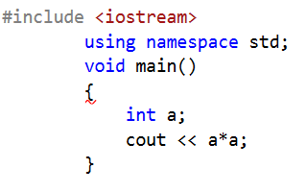?
- Where is the mistake of the code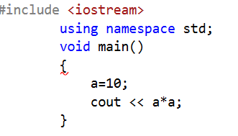?
- What will be printed in the part of the code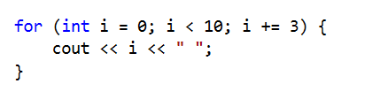?
AlgoritmizationProgrammingLanguages_PachshenkoGN/2
- What does the following statement mean?
int (*fp)(char*)
- pointer to a pointer`
- pointer to an array of chars
- pointer to function taking a char* argument and returns an int
- function taking a char* argument and returning a pointer to int
- The operator used for dereferencing or indirection is ____
- Choose the right option: string* x; string y;

- Which of the following is illegal?
- Where does the execution of the program starts?
- What are mandatory parts in function declaration?
- Which of the following is used to terminate the function declaration?
- Which operator is used for input stream?
- Which of the following correctly declares an array?

- What is the index number of the last element of an array with 9 elements?
- What is an array?
- Which of the following accesses the seventh element stored in array?
- The constants are also called as
- What are the parts of the literal constants?

- How the constants are declared?
- If a program uses Inline Function, then the function is expanded inline at______.
- If an argument to a function is declared as const, then
- What does C++ append to the end of a string literal constant?

- You have assigned the address of Value to the pointer P, Which statement will display the value stored in Value?
- A function that calls itself for its processing is known as
- Observe following function declaration and choose the best answer: int divide ( int a, int b = 2 )

- Variables inside parenthesis of functions declarations have _____ level access.
- Strings are character arrays. The last index of it contains the null-terminated character
- Regarding following statement which of the statements is true?
const int pathwidth=100;
- Which of the following are valid array declaration
- Following is the dereferencing operator

- Array elements are accessed using
- To perform File Input/Output operations, we must use _____________ header file.

- By default, all the files are opened in ___________mode

- What punctuation ends most lines of C++ code?

- Which of the following is not a correct variable type in C++?

- There is a unique function in C++ program by where all C++ programs start their execution
- Which of the following can not be used in identifiers?
- Which of the following is not a valid escape code?
- To increase the value of c by one which of the following statement is wrong?
- When following piece of code is executed, what happens? b=3; a=b++;
- The result of a Relational operation is always
- Which of the following is not a valid relational operator?
- By default, the standard output device for C++ programs is
- By default, the standard input device for C++ program is

- Looping in a program means
- If the type specifier of parameters of a function is followed by an ampersand &, that function call is
- What is the final value of x when the code <xmp>int x; for(x=0; x<28; x++) {} </xmp>is run?

